Toshi’s epic notes on assignment problem

<http://www.cse.ust.hk/~golin/COMP572/Notes/Matching.pdf>

Definitions

A graph $G=\left(V,E\right)$ is bipartite if there exists partition $V=X∪Y$ with $X∩Y=∅$ and $E⊆X×Y$.

A matching is a subset $M⊆E$ such that $∀v∈V$ at most 1 edge in $M$ is incident upon $v$.

The size of a matching is $\left|M\right|$, the number of edges in $M$.

A maximum matching is matching $M$ such that every other matching $M'$ satisfies $\left|M^{'}\right|≤\left|M\right|$

Weighted bipartite graphs are bipartite graphs in which each edge $\left(i, j\right)$ has a weight $w\left(i, j\right)$.

The weight of a matching $M$ is the sum of weights of edges in $M$. $w\left(M\right)=\sum_{e∈M}{w\left(e\right)}$

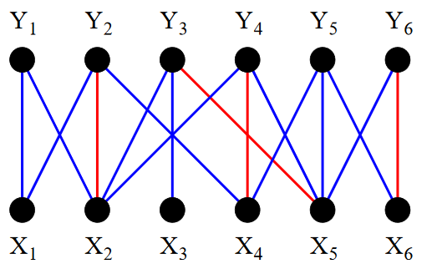WLOG, we may assume $G$ is a complete bipartite weighted graph by adding edges of weight $0$.

Vertex $v$ is matched if it is an endpoint of edge in $M$. Otherwise, $v$ is free.

$X_{2},X_{4},X_{5},X_{6},Y_{2},Y_{3},Y_{4},Y_{6}$ are matched, and others are free.

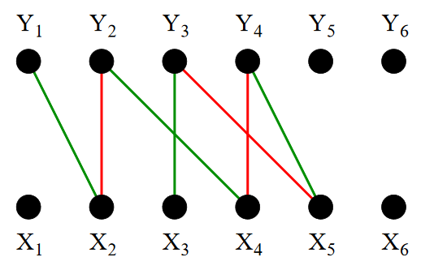All paths in a bipartite graph alternate between $X$ and $Y$.

A path is alternating if its edges alternate between $M$ and $E∖M$.

An alternating path is augmenting if both its endpoints are free.

The path $Y_{1},X_{2},Y_{2},X_{4},Y_{4},X_{5},Y_{3},X_{3}$ is an augmenting path because it is alternating and $Y_{1}$ and $X_{3}$ are free.

Important observation: Augmenting path can help us expand out matching. Swap the $M$ edges and the $E∖M$ edges in the path, and $M$ will still be a valid matching. There is 1 more $E∖M$ edges than $M$ edges in the path, so the new $M$ will increase in size by 1.

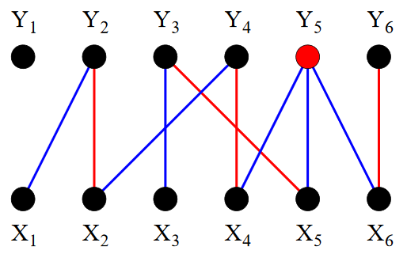An alternating tree is a tree rooted at some free vertex in which every path starting from the root is an alternating path.

Let $G$ be a complete bipartite graph. The assignment problem is to find a max weight matching in $G$. A perfect matching is an $M$ in which every vertex is adjacent to some edge in $M$. A max weight matching is always perfect.

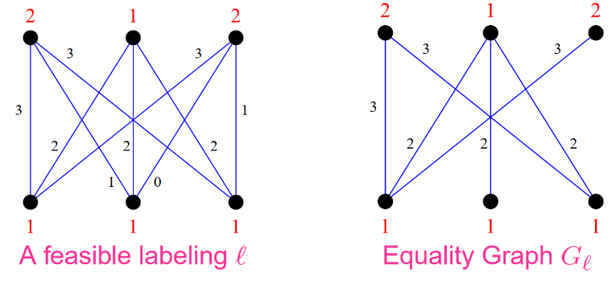Labelings

A vertex labeling is a function $l:V→R$.

A feasible labeling is a labeling such that $l\left(x\right)+l\left(y\right)≥w\left(x, y\right), ∀x∈X, y∈Y$.

The equality graph of a labeling $l$ is $G_{l}=\left(V, E_{l}\right)$ where $E_{l}=\left\{\left(x,y\right):l\left(x\right)+l\left(y\right)=w\left(x,y\right)\right\}$.

Kuhn-Munkres theorem: if $l$ is feasible and $M$ is a perfect matching in $E_{l}$, $M$ is a max weight matching.

Very big brain proof:

Let $M'$ be any perfect matching in $E$. Since every $v∈V$ is covered exactly once by $M'$,

$$w\left(M^{'}\right)=\sum_{e∈M^{'}}{w\left(e\right)}≤\sum_{e∈M^{'}}{l\left(e_{x}\right)+l\left(e_{y}\right)}=\sum_{v∈V}{l\left(v\right)}$$

Let $M$ be any perfect matching in $E_{l}$.

$$w\left(M\right)=\sum_{e∈M}{w\left(e\right)}=\sum_{e∈M}{l\left(e_{x}\right)+l\left(e_{y}\right)}=\sum_{v∈V}{l\left(v\right)}$$

Therefore, $w\left(M^{'}\right)≤w\left(M\right)$ so $M$ is optimal.

The theorem transforms the problem from an optimization problem of finding a max weight matching into a combinatorial one of finding a perfect matching. It combinatorializes the weights. This is a classic technique in combinatorial optimization.

Basic outline

Start with any feasible labeling $l$ and a matching $M$ in $E_{l}$.

While $M$ is not perfect:

Find an augmenting path in $E_{l}$, increase the size of $M$.

If no augmenting path exists, improve $l$ to $l^{'}$ such that $E_{l}⊂E_{l^{'}}$.

In each step $\left|M\right|$ or $\left|E_{l}\right|$ must be increasing so the algorithm will terminate.

When the process terminates, $M$ will be a perfect matching in $E_{l}$, which means $M$ is an max weight matching by the Kuhn-Munkres theorem.

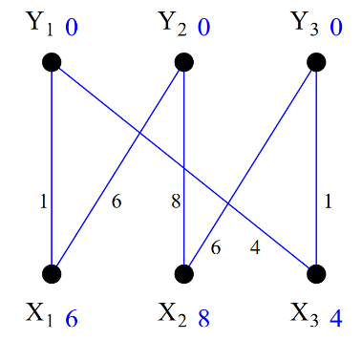

Initialization

$$l\left(x\right)=\max_{y∈Y}{w\left(x, y\right)}, ∀x∈X l\left(y\right)=0, ∀y∈Y$$

It is obvious that this labeling is feasible. For the initial matching, we can just start with an empty one.

Pick a free vertex $u∈X$ to be the root of an alternating tree. Set $S$ contains the vertices in $X$ and in the alternating tree, while set $T$ contains the vertices in $Y$ and in the alternating tree.

Initially, $S=\left\{u\right\}, T=∅$.

Improving the labeling

If $N_{l}\left(S\right)=T$, the matching $M$ in $E_{l}$ cannot be further improved, so $l$ must be improved to $l^{'}$ such that $E_{l}⊆E_{l^{'}}$.

$$α_{l}=\min_{x∈S, y∈Y∖T}{l\left(x\right)+l\left(y\right)-w\left(x, y\right)} l^{'}\left(v\right)=\left\{\begin{aligned}l\left(v\right)-α_{l} if v∈S \\ l\left(v\right)+α_{l} if v∈T \\ l\left(v\right) otherwise\end{aligned}\right.$$

After the change, we can see that edges originally in the alternating tree maintain the property that $l\left(x\right)+l\left(y\right)=w\left(x, y\right)$, but there will be new edges that also satisfy the condition, which are those that $α_{l}=l\left(x\right)+l\left(y\right)-w\left(x, y\right)$, because for those edges only $l\left(x\right)$ decreased the right amout to satisfy the condition.

Extending the alternating tree and finding augmenting path

Now $N_{l}\left(S\right)≠T$ (if it is, improve the labeling). Pick a vertex $y∈N_{l}\left(S\right)∖T$.

If $y$ is free, an augmenting path from the root of the alternating tree $u$ to $y$ is found! Update the matching and build the alternating tree again.

If $y$ is matched, we can extend the alternating tree. Let’s say $y$ is matched to $z$. We can add edges $\left(x∈S, y\right)$ and $\left(y, z\right)$ to the tree. $\left(x∈S, y\right)$ is in $E_{l}∖M$, and $\left(y, z\right)$ is in $M$. $z$ will never be in $S$ before adding the edges because the root $u$ is free and matched edge of another vertex $x∈S$ is already in the tree.

The Hungarian algorithm

Generate an initial labeling $l$ and a matching $M∈E_{l}$

while $M$ is not perfect:

pick a free vertex $u∈X$ to be the root of alternating tree $S=\left\{u\right\}, T=∅$.

while true:

if $N_{l}\left(S\right)=T$, improve $l$ to $l^{'}$

pick $y∈N_{l}\left(S\right)∖T$

if $y$ is free, update $M$ according to the augmenting path $u-y$, break

else, extend the alternating tree